AI Assisted Coding

Lab Test – 04 Date: 12.11.2025 24BTCAICSB01 and 24BTCAICSB02

SET 4

Q1. Design a Hospital Billing Database using AI.
- Include tables: Patients, Services, Bills.
- Insert Data in to these three tables
- Write SQL queries to calculate the total bill for each patient using a JOIN.
Q2. Using AI-generated Python code, normalize numeric columns in a healthcare dataset using Min-Max scaling and handle missing data with column medians. (First randomly generate some healthcare dataset to complete this task)

Q1 :
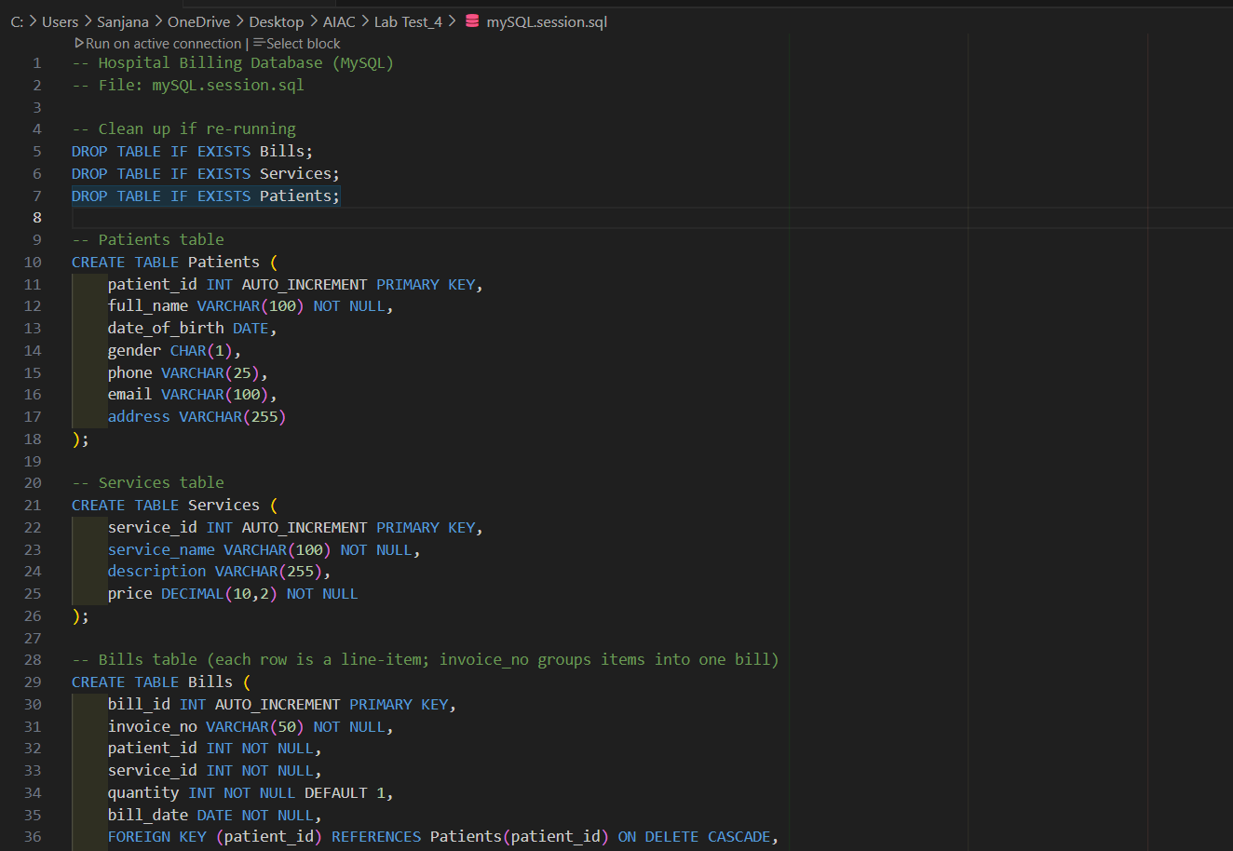
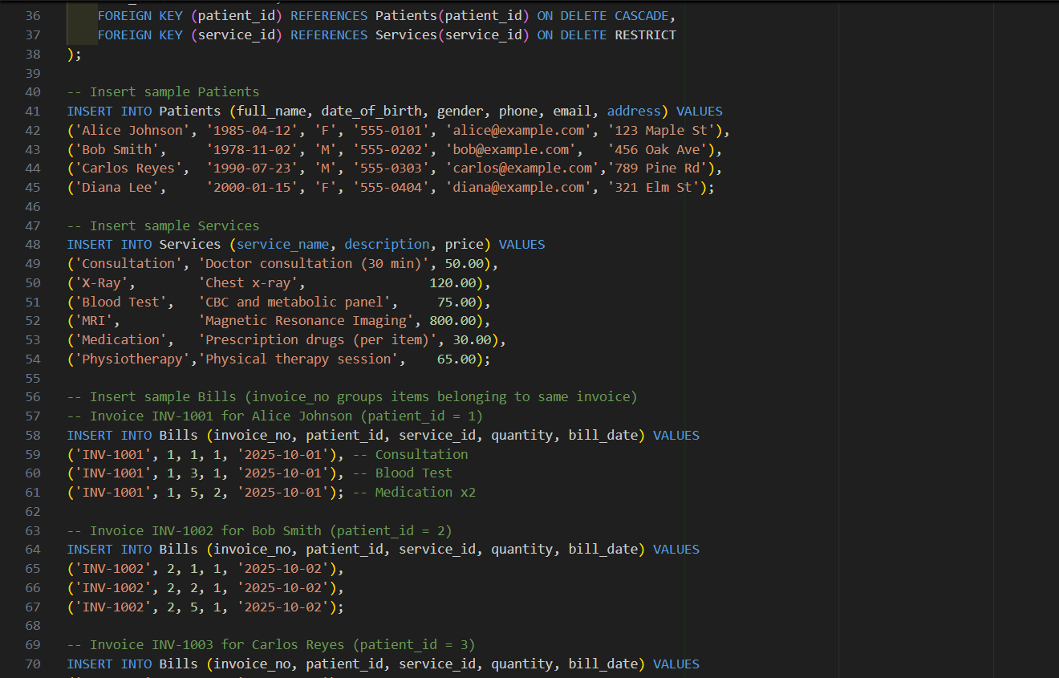
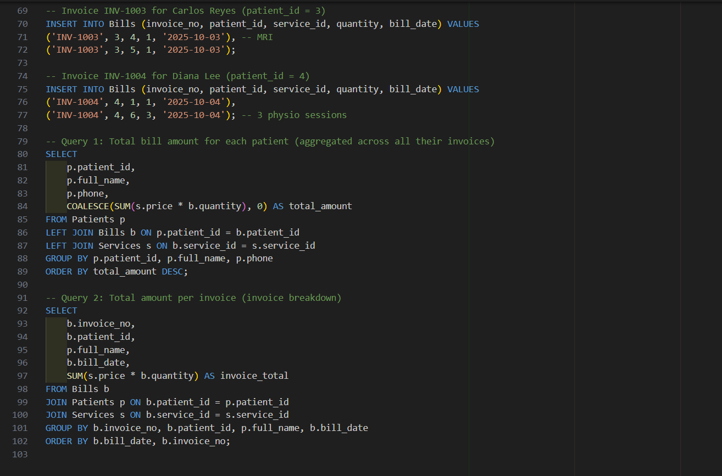

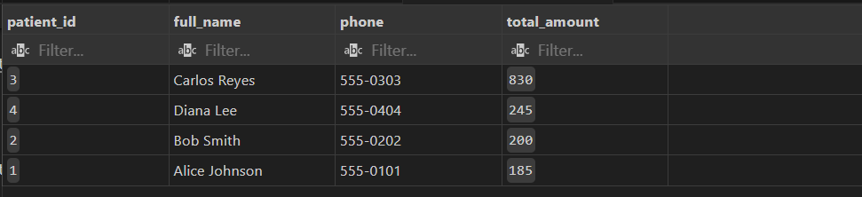
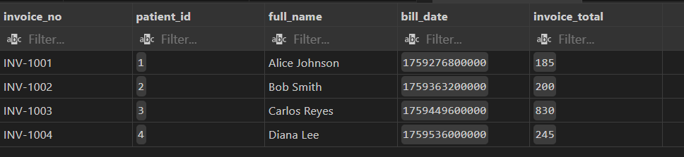

Q2 :
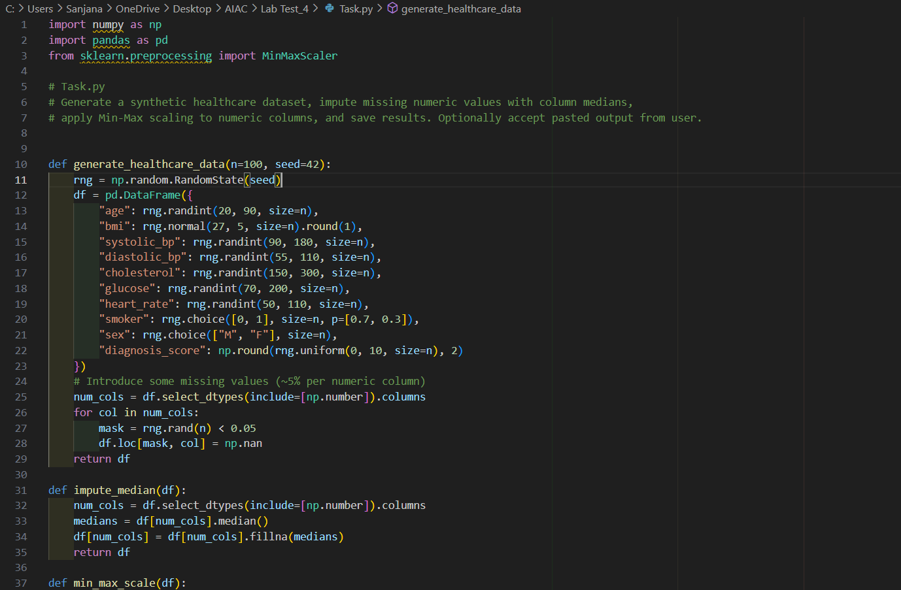
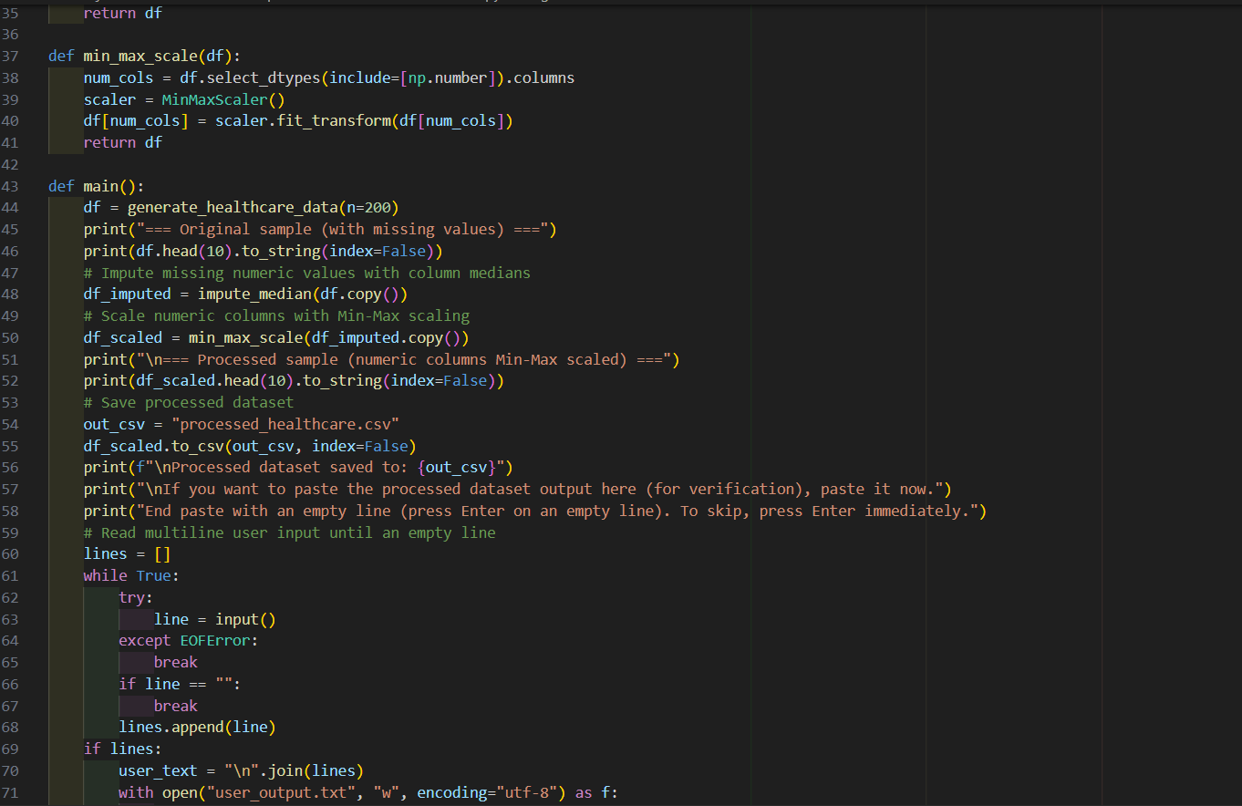
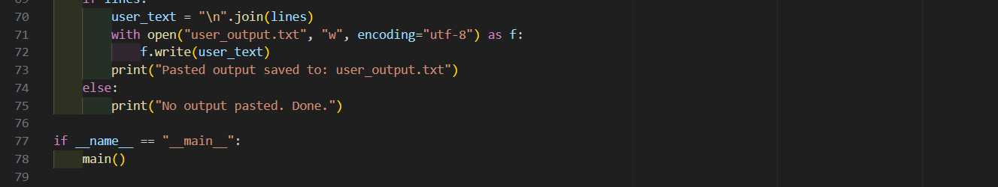

OUTPUT :
